LARGE SCALE MATRIX COMPUTATION BY PARALLEL COMPUTING

Anil Pavuluru (2782551)

a.pavuluru@vikes.csuohio.edu
Dept of MCIS, Cleveland State University

Abstract - The single-centre processors have now been supplanted by multicore processors to spare force. Accordingly, equal writing computer programs is actualized to utilize the numerous centres effectively. Parallelism can be cultivated with numerous centres inside a solitary framework (multiprocessor shared memory) or with independent centres from circulated frameworks (multiprocessor dispersed memory). The various approaches to uphold parallelism are circles, message passing interface (MPI), OpenMP and so forth Strings can be utilized for streamlining the exhibition of calculation concentrated projects in shared memory multiprocessor structures. To check the improvement accomplished utilizing strings, framework augmentation code composed utilizing java thread joins method.

In processing, equal programming model is a deliberation of equal PC engineering which makes it advantageous to adequately communicate calculations and their arrangement in projects and streamline the yield of the application

- INTRODUCTION
This paper presents the basic principle of Matrix Computation as well as case study of different methods to improve the matrix computation speed and constraints involved in the Memory allocation. Here we have initially started with Simple Matrix Method of matrix computation using java for different sizes of matrices ranging from 2⁴ to 2¹³ and tabulating the execution time for each of the computation followed by plotting the graph, later we came up with Parallel Computing using FORK JOIN Framework in java which uses multiple cores for Parallel execution and drastically increases the speed of execution which we come to know looking at the tabulated execution results obtained by compiling the matrix for different sizes. Finally, we implemented Custom Multi Thread Parallel matrix computation using Java on CUDA which is a GPU which uses the well-defined Hardware to increase the through put at the end all the plotted graphs are compared to explain the difference between the execution time for above three methods.
- CONCEPT
A. Matrix Multiplication: The concept of Matrix Multiplication in Mathematics is defined as a binary operation which involves two matrices and produces the resultant matrix. For the matrix multiplication the number of rows in the first matrix and the number of the columns in the second matrix need to be same. Each cell value in the resultant matrix is obtained by multiplying the i^{th} row of First matrix by the corresponding entries in the j^{th} column of Second matrix and then adding the results until all the cells are calculated this process continues till all the cell values in the matrix is calculated.
Note: In the project no need to check the condition above. Because it was square matrix(N*N). In square matrix always number of rows is equal to the number of columns.
B. Matrix subtraction: In subtraction, we subtract all the corresponding cells and repeat this process until all the cells are calculate.
C. Matrix Product: we must multiply each cell with fixed constant value of ‘2’.
D. Matrix Addition: In Addition, we add all the corresponding cells and repeat this process until all the cells are calculate.
Finally, the formula for calculation mentioned in the project X*Y-2*X+Y
- Matrix Initialization
- Here in the project, we initialize the matrix with random variables (2-D Array) of same size n*n for three methods.
- First steps we are assigning the matrix length and cores (keep track of thread creation).
- Second step assign number of rows for each thread.
- Then it checks the condition of cores if it initialize the object creation for three methods and assign the values. By, using random integer function.
- Initialise Core wc = new Initialise Core (matrixRs*w.Ra);
- MultiThread Wc = new Multi Thread (matrix X matriY.pruduct.Rs*w.Ra)
class Thread Job extends Thread
- Third method extends the runnable method of thread.

- Simple Matrix (Method-1)
- In this method we compute the large-scale matrix using java and the experiment analysis results are tabulates and plotted on a graph as shown in the fig 1,2.
- The following steps are performed for each of the value of n ranging (2⁴ to 2¹³)
- Allocating memory for two matrices X and Y depending on the value of n.
- Initialize each value of X and Y matrices using random generator function(nextInt) between -128 to 128.
- (maximum-minimum+1)+minimum max=128 and min=-128
( 128 - ( - 128 ) + 1 ) – 128 = 129.
- Calling the Spring boot starter parent timer function and recording the start time.
- Compute (X*Y) -2*X+Y
- Recalling the spring boot stater parent timer function and recoding the end time of the execution.sw.start(“simple matrix”)
- Calculating the execution time from the start and end time [Sw.stop();] and Tabulating the results which is shown in the fig.1
- Exit from the program and free the memory space.

- MULTI THREAD MATRIX (METHOD-2)

- The method of executing two or more threads/process parallelly on single multi core chip is known as parallel computing.
- In this method we compute the large-scale matrix using parallel computing Join method in java and experiment results are tabulated and plotted on graph as shown in the fig 1,3.
- The following steps are performed for each of the value of n ranging (2⁴ to 2¹³)
- The following steps are performed for each of the value of n ranging (2⁴ to 2¹³)
- Allocating memory for two matrices X and Y depending on the value of n.
- Initialize each value of X and Y matrices using random generator function(nextInt) between -128 to 128.
- (maximum-minimum+1)+minimum max=128 and min=-128
(128-(-128)+1)-128=129.
- Whenever assigning the values before it creates an object multithread, and it implements runnable method.
- Calling the Spring boot starter parent timer function and recording the start time.
- Compute (X*Y) -2*X+Y. Using row wise parallel calculation.
- Each thread calculates each row wise calculation and main method does not return results for each thread. It waits until each thread job to be completed TS[W]. join();
- Recalling the spring boot stater parent timer function and recoding the end time of the execution. [swcustommultimultiply matrix]
- Calculating the execution time from the start and end time sw.stop(); and Tabulating the results which is shown in the fig.1
- Exit from the program and free the memory space.

- CUSTOM PARALLEL MULTI THREAD MATRIX (METHOD-3)
- CUDA is used for parallel computing platform using NVIDIA. It can handle lot of operation with several cores. Supports big application in enterpriser.
- In this method we compute the large-scale matrix using custom parallel computing Join method in java and experiment results are tabulated and plotted on graph as shown in the fig 1,4.
- The following steps are performed for each of the value of n ranging (2⁴ to 2¹³)
- Allocating memory for two matrices X and Y depending on the value of n.
- Initialize each value of X and Y matrices using random generator function(nextInt) between -128 to 128.
(maximum-minimum+1)+minimum max=128 and min=-128 128-(-128)+1)-128=129. Whenever assigning the values before it creates an object multithread, and it implements runnable method.
- Calling the Spring boot starter parent timer function and recording the start time.
- Compute (X*Y) -2*X+Y. Using row wise parallel calculation.
- Each thread calculates each row wise calculation and main method does not return results for each thread. It waits until each thread job to be completed TS[W]. join();
- Recalling the spring boot stater parent timer function and recoding the end time of the execution. [ sw.start(“custom parallel multi thread Matrix”) ];
- Calculating the execution time from the start and end time [Sw.stop();]
and Tabulating the results which is shown in the fig.1
- Exit from the program and free the memory space.
- LIMITATIONS
- None of the three methods we coded are unbale to compute after n =2¹⁴
- This happens due to our program is running out of memory while initializing the matrix of size n=2¹⁴
- During initialization heap memory allocated for the process in the program by the memory manager is going out of java.lang.out.ofmemoryError:java heap space and execution get stopped. fig 6,7

- Spring Boot Framework
- Here in the project, we use spring boot parent stater to calculate time of the method execution.
- Lot of dependencies are there in the spring boot framework import org. spring framework. boot. Spring Application
- In this application we should use any hard coded value in the application that is why it shows in the fig6: output no active profile set up
- It calculates JVM running time, number of rows and columns, number of threads total time of task and three methods calculation time.

- EXPERIMENTAL RESULTS

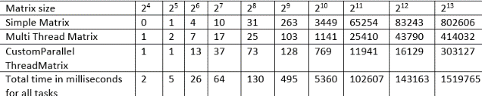

Fig 1: Comparison of Three method results

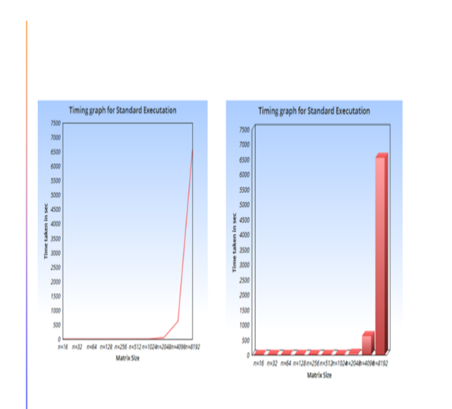
Fig 2: Simple matrix Graph

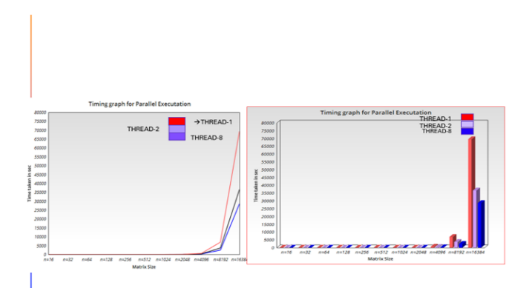
Fig 3: Multi Multiply Matrix Graph
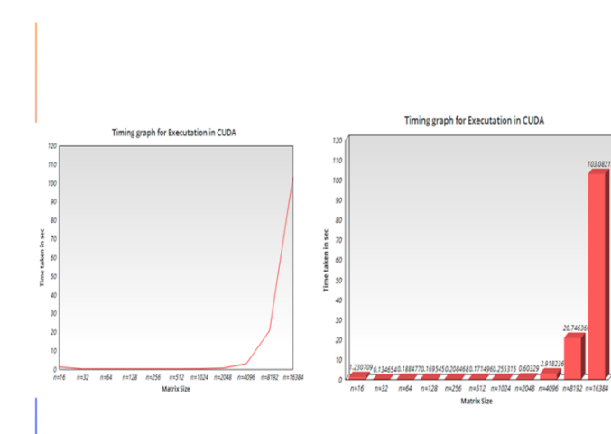

Fig 4: Custom Multi Multiply Matrix

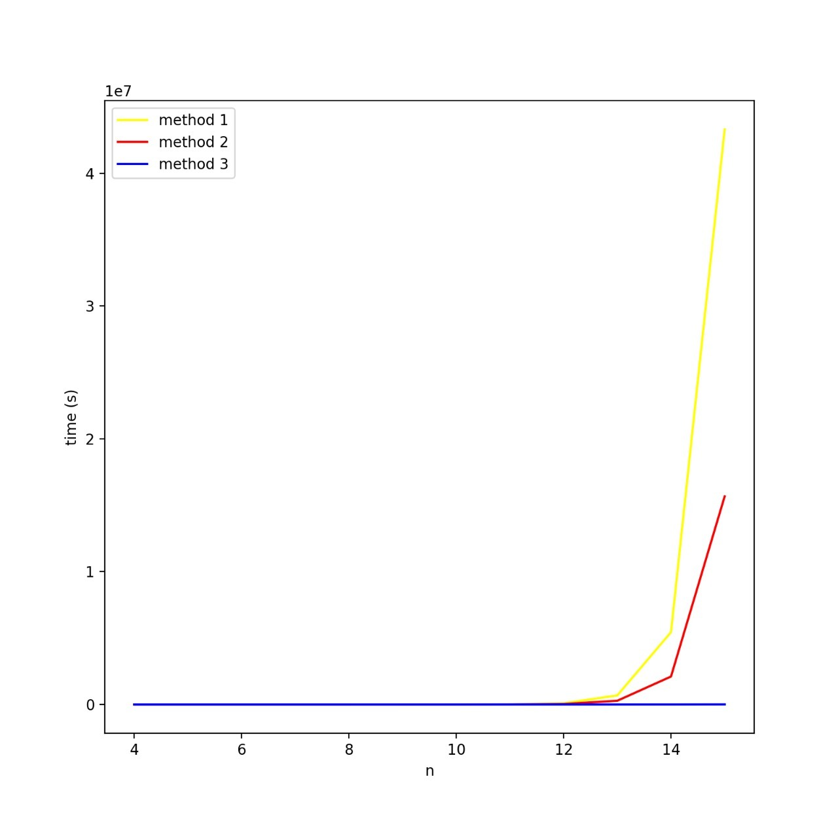
Fig 5: Three Methods Graph Comparison

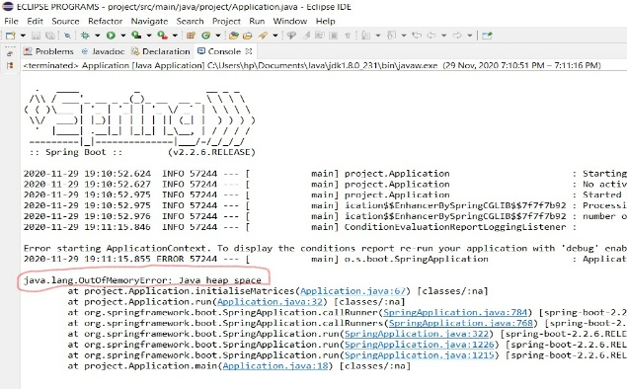
Fig 6:Limitation
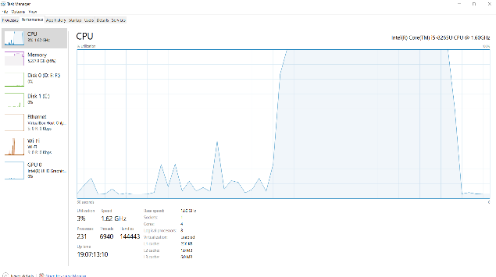
Fig 7: Taskeprfomance 2⁴ vs 2¹⁴

- Conclusion
- Finally, after comparing all the tabulated results we conclude that time to execute the matrix in Simple matrix is higher of all the three methods.
- Time taken to compute the matrix using multi multiply matrix computing in java is less than the Simple method and higher than the time taken to compute the Custom multiply matrix in CUDA Where the CUDA execution time is very much less as compared to the other method. The final comparison in fig.5

